**Week 7 Homework: A Day in the Life of a Windows Sysadmin**

1. Deliverable for Task 1:** Take a screenshot of all the GPOs created for this homework assignment. To find these, launch the Group Policy Management tool, select **Group Policy Objects**, and take a screenshot of the GPOs you've created.

**Answer: -**

**Task 1 - ScreenShot1**

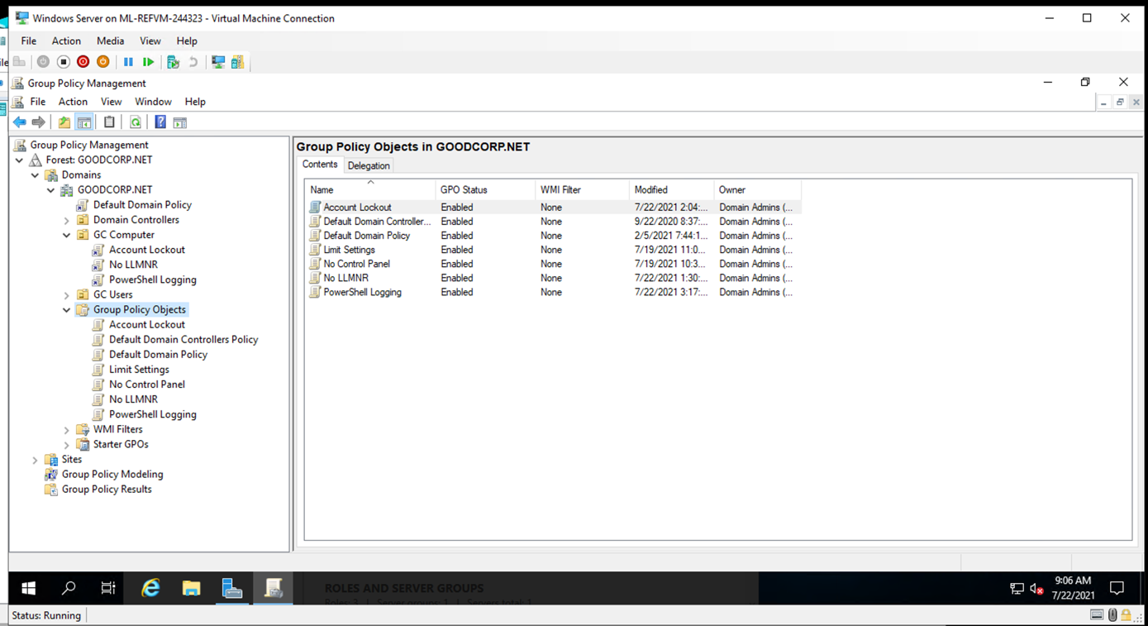

Task 1 - ScreenShot2

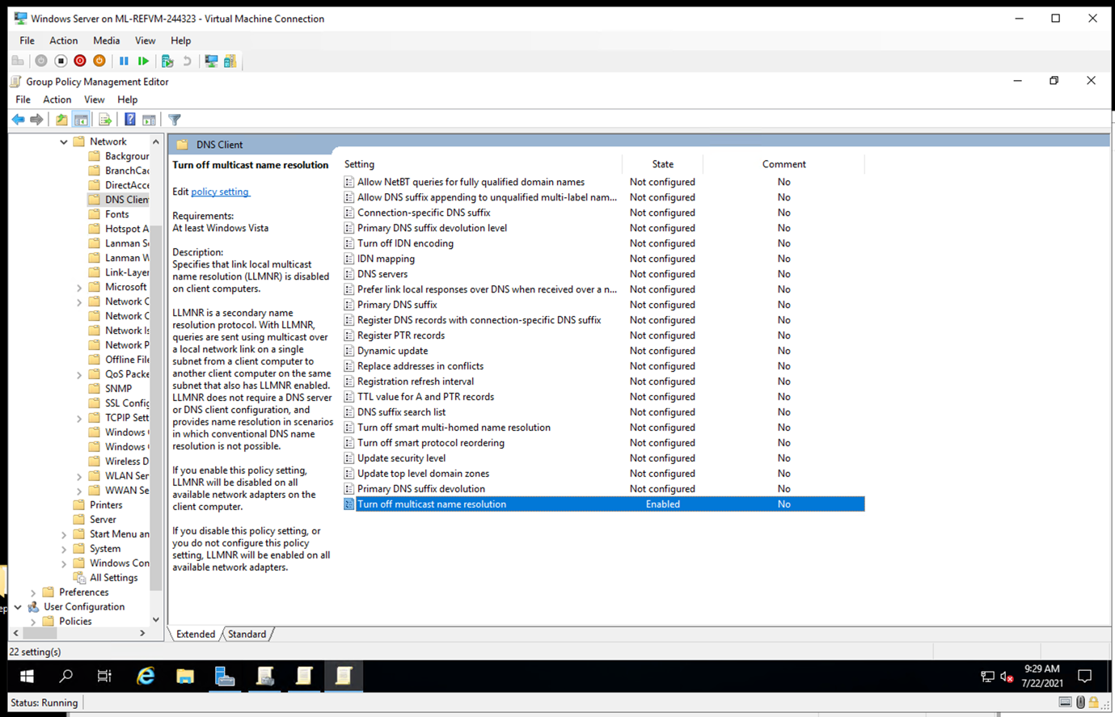

Task 1 – ScreenShot3

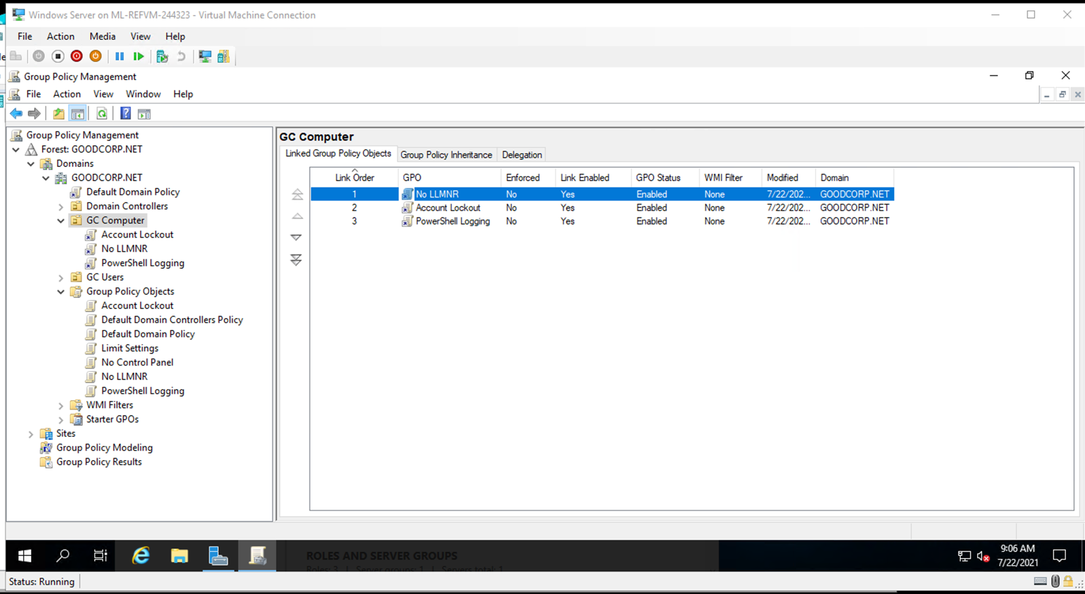

1. Deliverable for Task 2:** Submit a screenshot of the different `Account Lockout` policies in Group Policy Management Editor. It should show the three values you set under the Policy and Policy Setting columns.

**Answer: -**

Task 2 – ScreenShot1

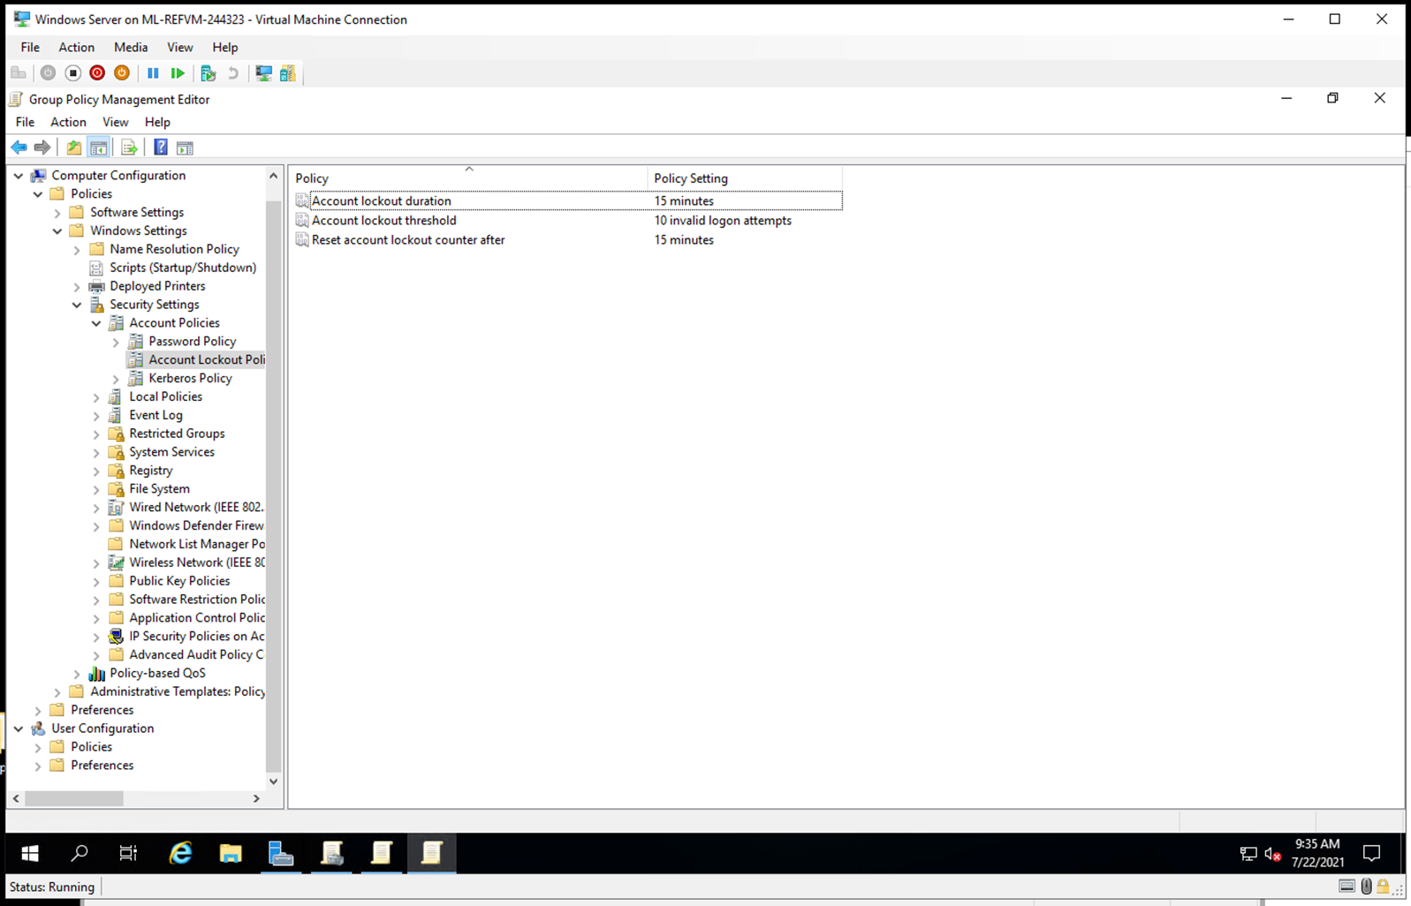

1. Deliverable for Task 3:** Submit a screenshot of the different `Windows PowerShell` policies within the Group Policy Management Editor. Four of these should be enabled.

**Answer: -**

Task 3 – ScreenShot1

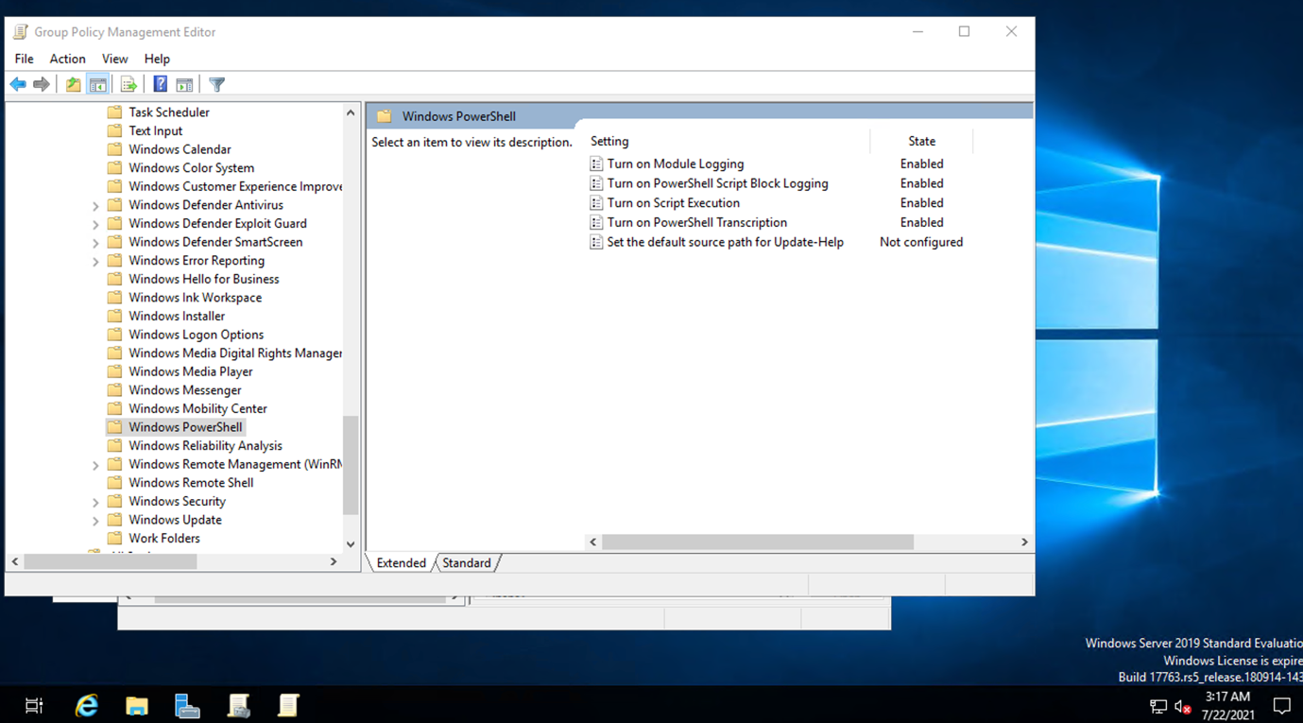

Task 3 – ScreenShot2

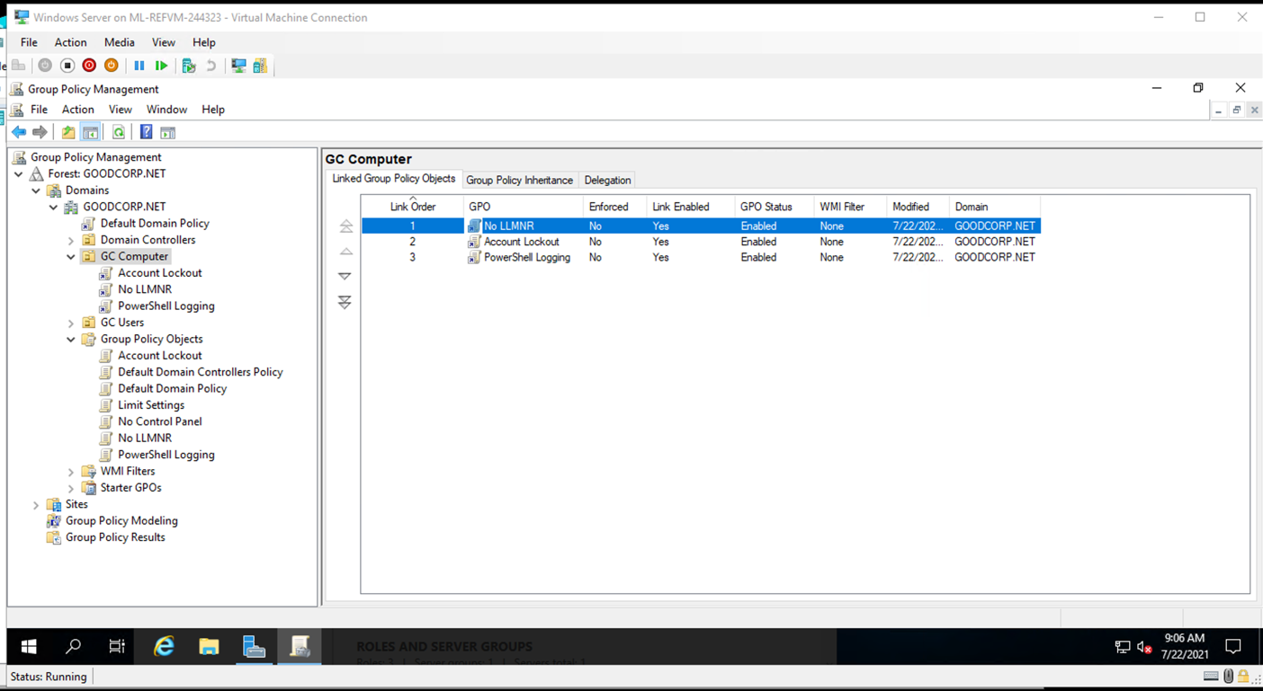

Task 3 – ScreenShot3

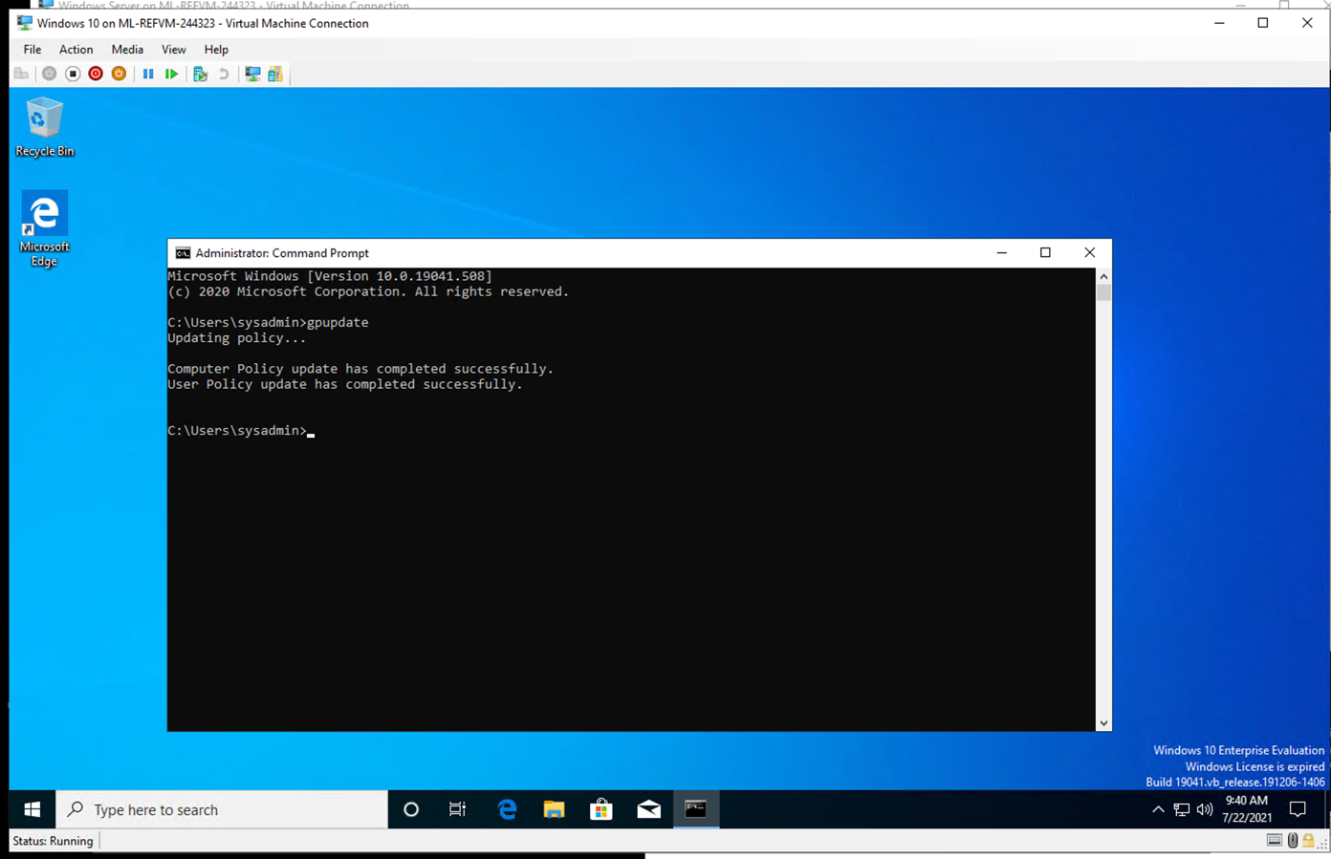

Task 3 – ScreenShot4

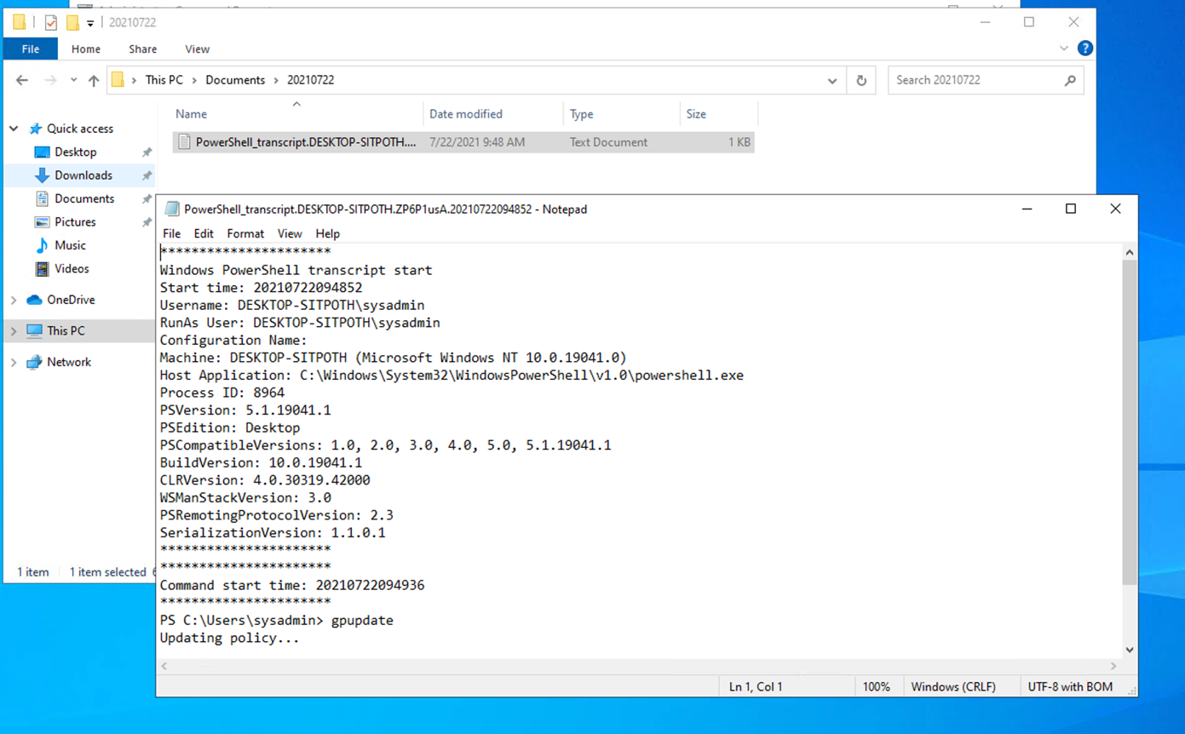

1. Deliverable for Task 4:** Submit a copy of your `enum_acls.ps1` script.

**Answer: -**

**$directory = Get-ChildItem**

**foreach ($item in $directory)**

**{**

**Get-Acl $item**

**}**

Task 4 – ScreenShot1

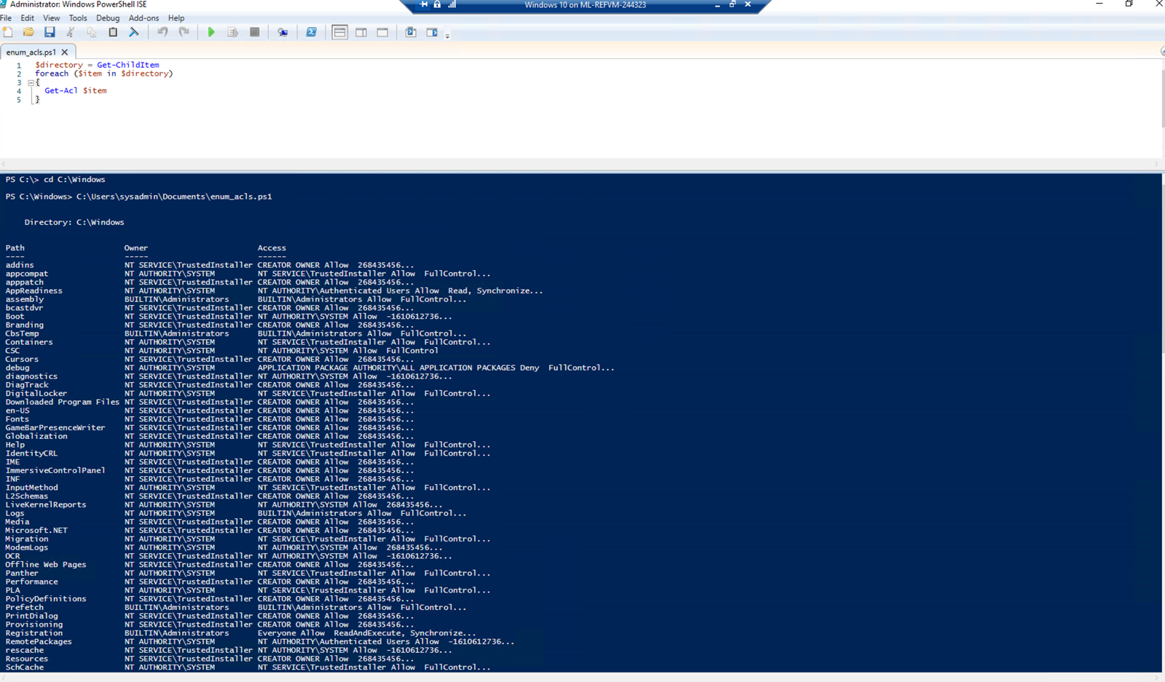

Task 4 – ScreenShot2

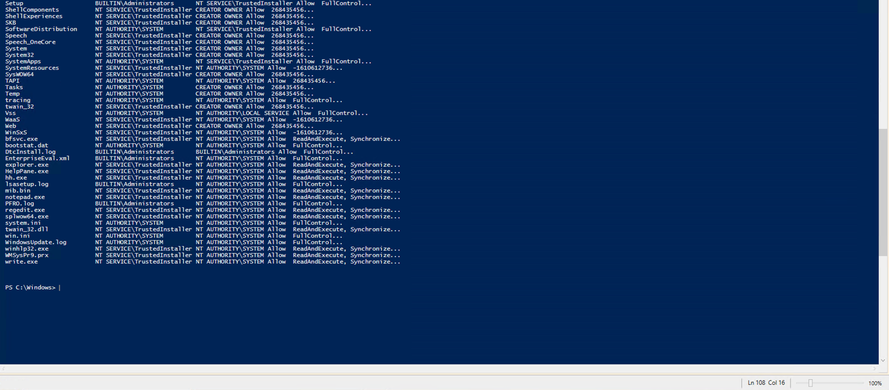

1. Deliverable for Bonus Task 5:** Submit a screenshot of the contents of one of your transcribed PowerShell logs or a copy of one of the logs.

**Answer: -**

Task 5 – ScreenShot1

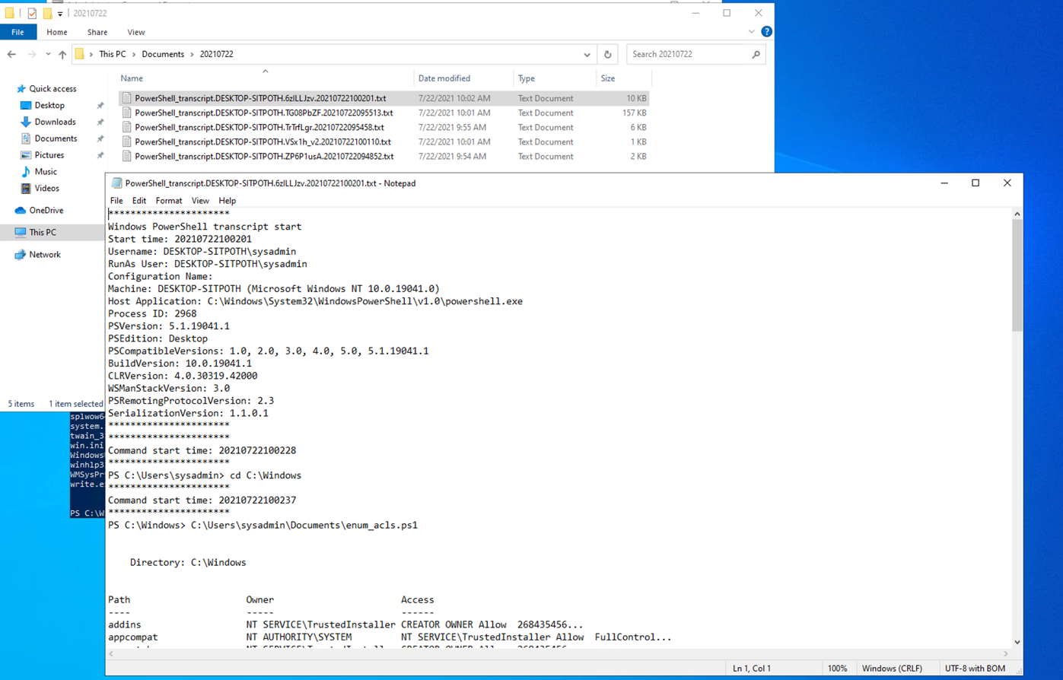

Also please find below link for log file.

<https://drive.google.com/file/d/1E026x5B6OWWOrpyWL5LoKGAJnqYyWDf3/view?usp=sharing>

And please find below link for all screen shorts.

<https://drive.google.com/drive/folders/1pke0Nm1sp7PGRDxUZW9ba4LS8M0AEMkT?usp=sharing>

Thank you,

Aziz Somani